FINAL PROJECT REPORT
PROBLEM 11
ONLINE SHOPPING PRODUCT OPTIMIZER
Algorithm-centric prototype using 0/1 Knapsack, Sorting and Binary Search
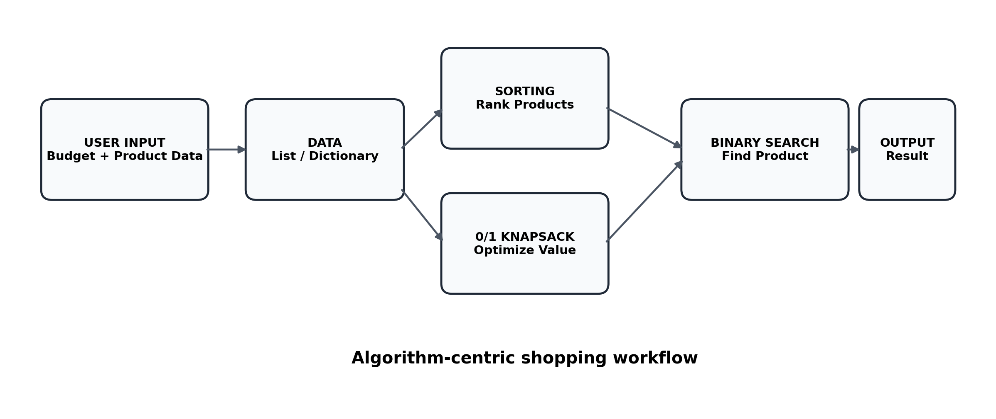
Figure 1. High-level workflow of the proposed shopping optimizer.

Submitted By
S. No | Student Name | Roll Number
1 | N.Vikas | 25MVCSMR0335
2 | N.Gowtham | 25MVCSMR0334
3 | A. Sravan kumar | 25MVCSMR0280
4 | Y.chandu reddy | 25MVCSMR0364
Department: Department of Computer Science and Engineering (AI&ML)
College: MALLA REDDY TECHNICAL CAMPUS
Academic Year: 2025–2029

1. Project Introduction
Project Title: ShopOpt – Online Shopping Product Optimizer
One-Line Idea: A smart shopping assistant that chooses the best combination of products within a given budget while maximizing a user-defined value such as rating, utility or discount.
Problem Domain: E-Commerce / Online Shopping

1.1 Project Overview
The Online Shopping Product Optimizer converts a real-world shopping requirement into a working algorithm-centric prototype. The system accepts product information such as price, value, rating and other relevant attributes, stores the information in a suitable data structure, and applies DAA algorithms to produce an understandable result.
The main purpose is not only to return a final number. The prototype should make important decisions visible, including which products were selected, the resulting objective value, and the number of comparisons or search steps used by the algorithms.

2. The Challenge

2.1 Problem Statement
Build a shopping assistant that chooses products under a budget while maximizing user-defined value such as rating, utility or discount.

2.2 Detailed Description
The system should convert the given real-world requirement into a working algorithm-centric prototype. It should accept the entities, relationships, resource values, costs, priorities or other information needed for the challenge and represent them using an appropriate data structure.
The prototype should make important decisions visible. For optimization or comparison, it should show the resulting objective value and enough information to explain why the result was selected.
The 0/1 Knapsack formulation treats each product as either selected or not selected and maximizes the required value without exceeding the budget. Binary Search operates on sorted data and repeatedly reduces the search interval by half. Sorting organizes records so ranking, searching, greedy selection or range queries can be performed efficiently. The implementation should expose comparisons or timing where appropriate.

2.3 Real-World Problem
- Customers often have a fixed budget and many product choices.
- Products can differ in price, rating, utility and discount.
- Manual comparison becomes difficult when several products can be purchased together.
- A final recommendation is more useful when the reasoning and algorithm steps are visible.

2.4 Why the Problem Matters
A transparent optimization tool can reduce manual comparison effort and help a user understand how a budget is being allocated. In an academic setting, the same problem provides a practical way to demonstrate optimization, sorting and searching algorithms in one application.

3. Objectives, Scope & Requirements

3.1 Objectives
- Maximize the stated value, benefit, coverage, capacity, score or reward.
- Demonstrate the selected DAA algorithms and compare their behavior where more than one approach is provided.
- Present the final result clearly so that users can understand the solution produced by the algorithm.

3.2 Functional Requirements
ID | Requirement | Description
FR1 | Accept budget and product details | User provides resource limit and product attributes.
FR2 | Represent product data | Store products using an appropriate structured data representation.
FR3 | Optimize selection | Choose a subset of products without exceeding the budget.
FR4 | Sort records | Arrange products by useful ranking criteria.
FR5 | Search records | Find a product using Binary Search on sorted data.
FR6 | Explain result | Show selected items, objective value and algorithm steps/comparisons.

4. Our Innovation

4.1 Core Idea
ShopOpt combines three DAA techniques in a single shopping workflow: Sorting prepares product records, 0/1 Knapsack makes the budget-constrained selection, and Binary Search provides efficient product retrieval from sorted records.

4.2 Key Features
- Budget-based product optimization
- Selection of products using 0/1 decisions
- Product ranking by price, rating or value
- Binary Search with visible search steps and comparison count
- Display of total cost and maximum objective value
- Explainable output rather than only a final result

4.3 Unique Approach
The solution is algorithm-centric and explainable. The user can see the selected products, objective value, search path and comparison information, making the DAA behavior understandable instead of hidden inside a black-box recommendation.
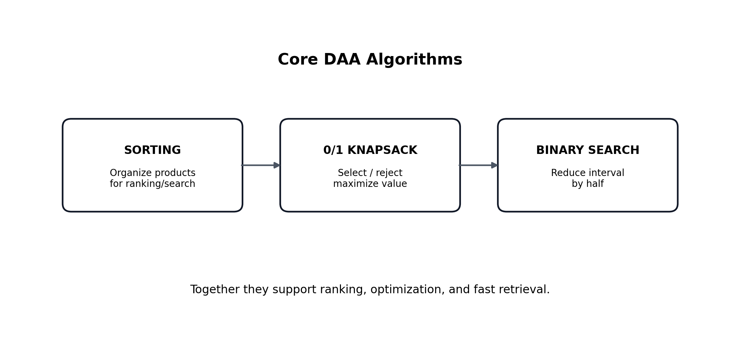
Figure 2. Relationship between the three core algorithms.

5. How It Works

5.1 Workflow
Figure 3. Input-to-output workflow for the prototype.

5.2 Input → Processing → Algorithm → Output
Stage | Details
Input | Budget; product name; price; rating; utility/value; discount or other priority information.
Processing | Store and organize product records; prepare sorted data when required.
Algorithm | Sorting; 0/1 Knapsack; Binary Search.
Output | Selected products, total cost, objective value, search result and step/comparison information.

5.3 User Journey
- Enter the available budget.
- Provide or load product information.
- View and sort products using a selected criterion.
- Run the optimizer to obtain a budget-feasible product combination.
- Search for a product and inspect Binary Search steps.
- Review the final selection, objective value and algorithm measurements.

6. Technology & Algorithm

6.1 Suggested Technology Stack
Layer | Technology | Purpose
Backend / Prototype | Python + Flask | Handles application logic and algorithm execution.
Frontend | React (suggested) / HTML + CSS prototype | Provides the user interface.
Database | SQLite (suggested) | Suitable for storing product and user-related records in a fuller implementation.
Data Structure | List of records / dictionaries | Stores product attributes such as price, value and rating.

6.2 Main Algorithms
Algorithm | Role in ShopOpt | Typical Complexity
0/1 Knapsack | Select or reject each item; maximize total value under the budget. | O(n × B)
Sorting | Arrange products for ranking, comparison and efficient preparation for search. | O(n log n)
Binary Search | Search sorted product records by repeatedly halving the search interval. | O(log n)

6.3 Why These Algorithms Were Chosen
0/1 Knapsack directly models the budget-constrained product selection problem. Sorting creates an ordered view that supports ranking and efficient preparation for search. Binary Search matches the requirement for fast retrieval from sorted data and makes the reduction of the search interval visible through search steps and comparisons.

7. Algorithmic Design

7.1 0/1 Knapsack Formulation
For each product i, define a binary decision xᵢ where xᵢ = 1 means the product is selected and xᵢ = 0 means it is not selected. Let cᵢ be its cost and vᵢ its user-defined value. The objective is to maximize Σ(vᵢxᵢ) subject to Σ(cᵢxᵢ) ≤ B, where B is the user budget.
The dynamic programming approach builds solutions for smaller budgets and smaller product sets, then uses those results to obtain the maximum achievable value for the full budget.

7.2 Sorting
The product records can be sorted by price, rating, value or another supported criterion. The sorted output is useful for product ranking and for preparing the data structure used by Binary Search.

7.3 Binary Search
Binary Search begins with the full sorted interval. It checks the middle record and then keeps only the half that can still contain the target. The prototype records each checked item and the total number of comparisons.

8. Demo & Impact

8.1 Prototype Demonstration
Demo | User Action | Visible Output
Budget Optimization | Enter a budget and run the optimizer. | Selected products; total cost; maximum value; DP comparison count.
Product Ranking | Choose price, rating or value sorting. | Ordered product list.
Product Search | Enter a product name. | Found product; search steps; comparison count.
Decision Explanation | Inspect the result produced by the algorithms. | Visible reasoning through selected items and measurements.

8.2 Expected Practical Benefits
- Supports budget-aware shopping decisions.
- Reduces the effort needed to compare many products manually.
- Provides a transparent explanation of algorithm-driven selection.
- Creates one compact application that demonstrates multiple DAA concepts.

8.3 Performance / Measurement
The prototype exposes algorithm-related measurements where appropriate. For Knapsack, the implementation can display the number of DP comparisons/iterations. For Binary Search, it displays the number of comparisons and the sequence of checked records. Sorting can be evaluated using its complexity or, where implemented, execution timing.

9. Future Vision

9.1 Current Achievement
The project defines a working algorithm-centric prototype concept in which product data, budget constraints, optimization, sorting and searching are connected in one user flow.

9.2 Future Improvements
- Connect to a persistent SQLite database for product records.
- Add a React-based frontend for a richer interactive user experience.
- Allow users to choose the optimization objective, such as rating, utility or discount.
- Add more product attributes and multi-criterion comparison.
- Support larger product datasets and additional optimization strategies.
- Provide charts or dashboards for algorithm timing and comparison analysis.

9.3 Scalability
The design can be expanded from a small prototype to a larger shopping-assistance system by separating the user interface, data storage and algorithm modules. The same algorithmic structure can then be reused with larger product catalogs and richer user preferences.

9.4 Final Takeaway
ShopOpt turns a common online-shopping decision into an understandable DAA problem: organize the products, search efficiently, and choose a budget-feasible combination that maximizes the user-defined value.

10. Conclusion
The Online Shopping Product Optimizer addresses the given Problem 11 requirements by treating shopping selection as a 0/1 Knapsack problem and supporting the surrounding workflow with Sorting and Binary Search. The design emphasizes explainability by exposing selected products, objective value and algorithm steps or comparisons. This makes the project suitable both as a practical prototype and as a clear demonstration of Design and Analysis of Algorithms concepts.

11. Problem Statement Reference
This report is based on the problem statement and detailed challenge information supplied for “PROBLEM 11: Online Shopping Product Optimizer,” including the specified core algorithms (0/1 Knapsack, Sorting, Binary Search), suggested technologies (Python/Flask, React, SQLite), and stated objectives.

